Here is a comprehensive and detailed course book designed for a 14-week semester, specifically tailored for a 3-hour weekly lecture format. I have integrated specific Kenyan illustrations and context to make the material relevant to your students at Multimedia University of kenya.

# Course Book: Wireless Networks & Mobile Computing

Target Audience: Undergraduate/Postgraduate Computer Science Students

Context: Kenyan Telecommunications Environment

## Week 1: Fundamentals of Wireless Networks

Lecture Duration: 3 Hours

Goal: To transition students from fixed computing paradigms to mobile concepts and understand the Kenyan wireless landscape.

### 1.1 Introduction to Mobile Computing

* **Definition:** Mobile Computing is an umbrella term for technologies enabling access to network services anywhere, anytime, and anyplace1. It is distinct from "Portable Computing" (where you move a device but use it in a fixed state). Mobile computing implies computing *while* moving.
* **The Paradigm Shift:** It moves away from the "Fixed and Wired" model (desktop in an office) to the "Mobile and Wireless" model (unrestricted roaming)2222.
* **Kenyan Context:**
  + *Illustration:* Compare a Cyber Cafe in Nairobi CBD (Fixed/Wired) to a boda-boda rider checking orders on Uber Eats (Mobile/Wireless).

### 1.2 Transmission Modes

* **Simplex:** One-way communication.
  + *Example:* Standard FM Radio (Kiss 100, Classic 105). You receive signal but cannot transmit back.
* **Half-Duplex:** Two-way communication, but only one party transmits at a time.
  + *Example:* Walkie-Talkies used by security guards (Askalis) at Zetech University gates.
* **Full-Duplex:** Simultaneous two-way communication.
  + *Example:* A GSM phone call on the Safaricom network.

### 1.3 Wireless Services & Applications

1. **Vehicles (Telematics):** Transmission of news, road conditions, and GPS position.
   * *Kenyan Context:* "Matatu" tracking systems used by NTSA; Uber/Bolt/Little Cab using GPS for location.
2. **Emergencies:** Ad-hoc networks replacing destroyed infrastructure3.  
   * *Kenyan Context:* AMREF Flying Doctors transmitting patient vitals from remote areas (e.g., Turkana) to Nairobi Hospital while in flight.
3. **Business:** The "Mobile Office."
   * *Kenyan Context:* Sales agents for companies like Equity Bank using tablets to open accounts in the field (Agency Banking).
4. **Infotainment:** Location-based services.
   * *Kenyan Context:* Google Maps showing traffic jams on Thika Road.

### 1.4 Limitations of Mobile Computing

* **Resource Constraints:** Mobile devices have limited battery and memory compared to desktops4.
* **Interference:** Wireless signals are susceptible to shielding (e.g., entering a basement parking in Westlands and losing signal)5.
* **Bandwidth:** Wireless data rates (even 4G) are generally lower and more expensive than wired fiber (e.g., Faiba/Zuku)6.
* **Security:** Higher risk of device theft and eavesdropping over the air interface7.

## Week 2: Modulation Techniques

Lecture Duration: 3 Hours

Goal: Understand the physics of transmitting bits over the air.

### 2.1 The Communication Block

Every wireless transmission follows this path:

Source -> Modulator -> Channel (Air) -> Demodulator -> Destination

* **The Physical Layer:** Responsible for frequency selection, carrier generation, and modulation8.

### 2.2 Analog Modulation

* **Concept:** Modulating a sine wave $v(t) = A \sin(2\pi ft + \phi)$ by varying Amplitude, Frequency, or Phase.
* **Amplitude Modulation (AM):** Varying signal strength. Prone to noise.
* **Frequency Modulation (FM):** Varying frequency.
  + *Kenyan Context:* 88 MHz – 108 MHz band used by Kenyan radio stations. FM is clearer than AM because noise affects amplitude, not frequency.

### 2.3 Digital Modulation (Part 1)

* **Why Digital?** Computers process binary (0s and 1s). We must map these bits onto analog airwaves.
* **Amplitude Shift Keying (ASK):** 1 = High Amplitude, 0 = Low Amplitude.
* **Frequency Shift Keying (FSK):** 1 = Frequency $f_1$, 0 = Frequency $f_2$.
* **Phase Shift Keying (PSK):** 1 = Phase $0^\circ$, 0 = Phase $180^\circ$.
* **GMSK (Gaussian Minimum Shift Keying):**
  + Used specifically in **GSM** networks.
  + It is a refined FSK where the phase change is smoothed (Gaussian filter) to reduce bandwidth usage9.

## Week 3: Advanced Modulation

Lecture Duration: 3 Hours

Goal: High-speed data transmission (3G/4G/5G concepts).

### 3.1 Advanced Digital Modulation

* **QPSK (Quadrature Phase Shift Keying):**
  + Uses 4 different phases ($45^\circ, 135^\circ, 225^\circ, 315^\circ$).
  + Encodes **2 bits per symbol** (00, 01, 10, 11).
  + *Benefit:* Doubles the data rate of standard PSK without increasing bandwidth.
* **QAM (Quadrature Amplitude Modulation):**
  + Changes both Amplitude and Phase.
  + **16-QAM:** 16 states (4 bits per symbol).
  + **64-QAM:** 64 states (6 bits per symbol).
  + *Kenyan Context:* Used in Digital TV broadcasting (Signet/Pang) and high-speed Safaricom 4G LTE links.

### 3.2 OFDM (Orthogonal Frequency Division Multiplexing)

* **Concept:** Instead of sending high-speed data on one frequency (which causes echoes/multipath fading), split the data into hundreds of slow-speed sub-carriers.
* **Orthogonality:** The peak of one sub-carrier aligns with the nulls of others, preventing interference.
* *Application:* The foundation of **Wi-Fi (802.11a/g/n/ac)** and **4G/5G** networks.

## Week 4: Speech Coding

Lecture Duration: 3 Hours

Goal: How voice is converted to bits for GSM.

### 4.1 Characteristics of Speech

* Human voice contains frequencies from ~300 Hz to 3400 Hz.
* **GSM Goal:** Transmit high-quality digital voice using minimal bandwidth10.

### 4.2 PCM (Pulse Code Modulation)

1. **Sampling:** Based on Nyquist Theorem ($2 \times f_{max}$), voice is sampled at 8000 times per second.
2. **Quantization:** Assigning a digital value to the amplitude of each sample.
   * *Uniform vs. Non-Uniform:* GSM uses non-uniform quantization to capture the subtleties of human speech better.
3. **Encoding:** Converting the value to binary (8 bits).
   * Total Rate: $8000 \times 8 = 64 \text{ kbps}$ (This is the standard "DS0" rate used in ISDN and fixed lines).

### 4.3 GSM Specific Coding

* Wireless cannot afford 64 kbps per user.
* **Vocoders:** GSM uses Linear Predictive Coding (LPC) to compress voice down to **13 kbps** (Full Rate) or **6.5 kbps** (Half Rate) 11.
* *Kenyan Context:* When the Safaricom network is congested (e.g., New Year's Eve), the network might switch users to "Half Rate" coding. You might notice the voice sounds slightly more robotic/metallic.

## Week 5: Multiple Access Techniques

Lecture Duration: 3 Hours

Goal: How 30 million Kenyans share the airwaves without blocking each other.

### 5.1 Multiplexing vs. Multiple Access

* **Multiplexing:** One user sending multiple signals (e.g., Left and Right audio channels).
* **Multiple Access:** Many users sharing the same medium (e.g., 50 people making calls in one GSM cell).

### 5.2 FDMA (Frequency Division Multiple Access)

* **Concept:** Giving each user a specific frequency (like radio stations).
* **GSM Implementation:** GSM uses **FDD (Frequency Division Duplexing)**.
  + Uplink (Phone to Tower): 890–915 MHz.
  + Downlink (Tower to Phone): 935–960 MHz 12.
  + Each channel is 200 kHz wide13.

### 5.3 TDMA (Time Division Multiple Access)

* **Concept:** Giving each user a specific *time slot*.
* **GSM Implementation:** GSM divides every frequency channel into **8 time slots** (Frames).
* **The Burst:** A user transmits data in a slot for only **577 microseconds**. This data packet is called a "Burst" 14.
* *Kenyan Context:* This is why if you put a GSM phone near a cheap radio/speaker, you hear a "dit-dit-dit" buzzing sound. That is the TDMA burst pulsing on and off 217 times per second.

## Week 6: Multiple Access (Cont.)

Lecture Duration: 3 Hours

Goal: Advanced access schemes and Packet Radio.

### 6.1 CDMA (Code Division Multiple Access)

* **Concept:** Everyone talks at the same time on the same frequency, but in different languages (Codes).
* **Spreading:** Uses "Chipping Sequences" (Orthogonal codes) to spread the signal.
* **Encryption:** Inherently secure; interference looks like white noise 15.
* *Kenyan Context:* CDMA technology was used by **Telkom Kenya (Orange)** for their landline wireless phones and early internet dongles before they moved to GSM/4G.

### 6.2 Packet Radio: Aloha

* **Pure Aloha:** Transmit whenever you want. High collision rate. (18% efficiency).
* **Slotted Aloha:** Transmit only at the beginning of a synchronized time slot. (36% efficiency) 16.
* *Application:* GSM uses Slotted Aloha for the **RACH (Random Access Channel)**—the channel your phone uses to ask for a connection when you first press "dial" 17.

### 6.3 CSMA (Carrier Sense Multiple Access)

* **Protocol:** "Listen before you talk."
* **Hidden Terminal Problem:** Node A talks to B. Node C cannot hear A, so C talks to B, causing a collision. A is hidden from C 18.
* **Solution (MACA):** Use control packets **RTS (Request to Send)** and **CTS (Clear to Send)** to reserve the airwaves19.

## Week 7: The Cellular Concept

Lecture Duration: 3 Hours

Goal: How mobile networks cover large areas (Geometry of coverage).

### 7.1 The Hexagonal Cell

* Why Hexagons? They cover an area without gaps or overlaps (unlike circles) and approximate an omni-directional signal better than squares.

### 7.2 Frequency Reuse

* **Concept:** Frequencies are a scarce resource. We cannot give every tower a unique frequency.
* **Clusters:** We group cells into clusters (e.g., size $N=7$). We use unique frequencies in the cluster, then *reuse* the same frequencies in the next cluster 20.
* *Kenyan Context:* A Safaricom tower in Juja can use the same frequency as a tower in Westlands because they are far enough apart not to interfere.

### 7.3 Handoff (Handover)

* **Definition:** The process of transferring a call from one Base Station to another as the user moves.
* **Hard Handover:** "Break before make." The connection to the old tower is cut before the new one is made (used in GSM).
* **Soft Handover:** "Make before break." Connected to both towers simultaneously for a moment (used in 3G/CDMA) 21.
* **Scenarios:**
  + *Intra-cell:* Changing frequency due to interference.
  + *Inter-cell (Intra-BSC):* Moving between towers managed by one controller22.
  + *Inter-MSC:* Moving from Nairobi region to Nakuru region (different switches)23.

## Week 8: Capacity Expansion

Lecture Duration: 3 Hours

Goal: Handling high user density in cities like Nairobi.

### 8.1 Cell Splitting

* Dividing a large cell (Macrocell) into smaller cells (Microcells) by adding more low-power towers.
* *Kenyan Context:* In Nairobi CBD, antennas are placed on almost every tall building. These are microcells to handle the high density of people. In Turkana, towers are kilometers apart (Macrocells).

### 8.2 Sectoring

* Replacing an omni-directional antenna (360 degrees) with directional antennas (e.g., three 120-degree antennas).
* **Benefit:** Reduces interference and allows frequency reuse, increasing capacity24.

### 8.3 Microcell Zone Concept

* Using fiber optics to distribute signals to remote antennas, making the "cell" follow the user.

## Week 9: GSM Architecture & Mobile TCP

Lecture Duration: 3 Hours

Goal: Detailed look at 2G architecture and Transport layer issues.

### 9.1 GSM Architecture (The Backbone)

1. **Mobile Station (MS):** The physical phone + SIM (Subscriber Identity Module)25.
2. **Base Station Subsystem (BSS):**
   * **BTS (Base Transceiver Station):** The tower/radio equipment.
   * **BSC (Base Station Controller):** The "brain" controlling radio resources and handovers for several BTSs 26.
3. **Network Switching Subsystem (NSS):**
   * **MSC (Mobile Switching Center):** The core switch connecting calls.
   * **HLR (Home Location Register):** Database of your permanent details (SIM profile, plan).
   * **VLR (Visitor Location Register):** Database of where you are *currently* 27.
   * *Example:* If you live in Mombasa (Home) but travel to Kisumu (Visitor), the Kisumu VLR requests your profile from the Mombasa HLR.

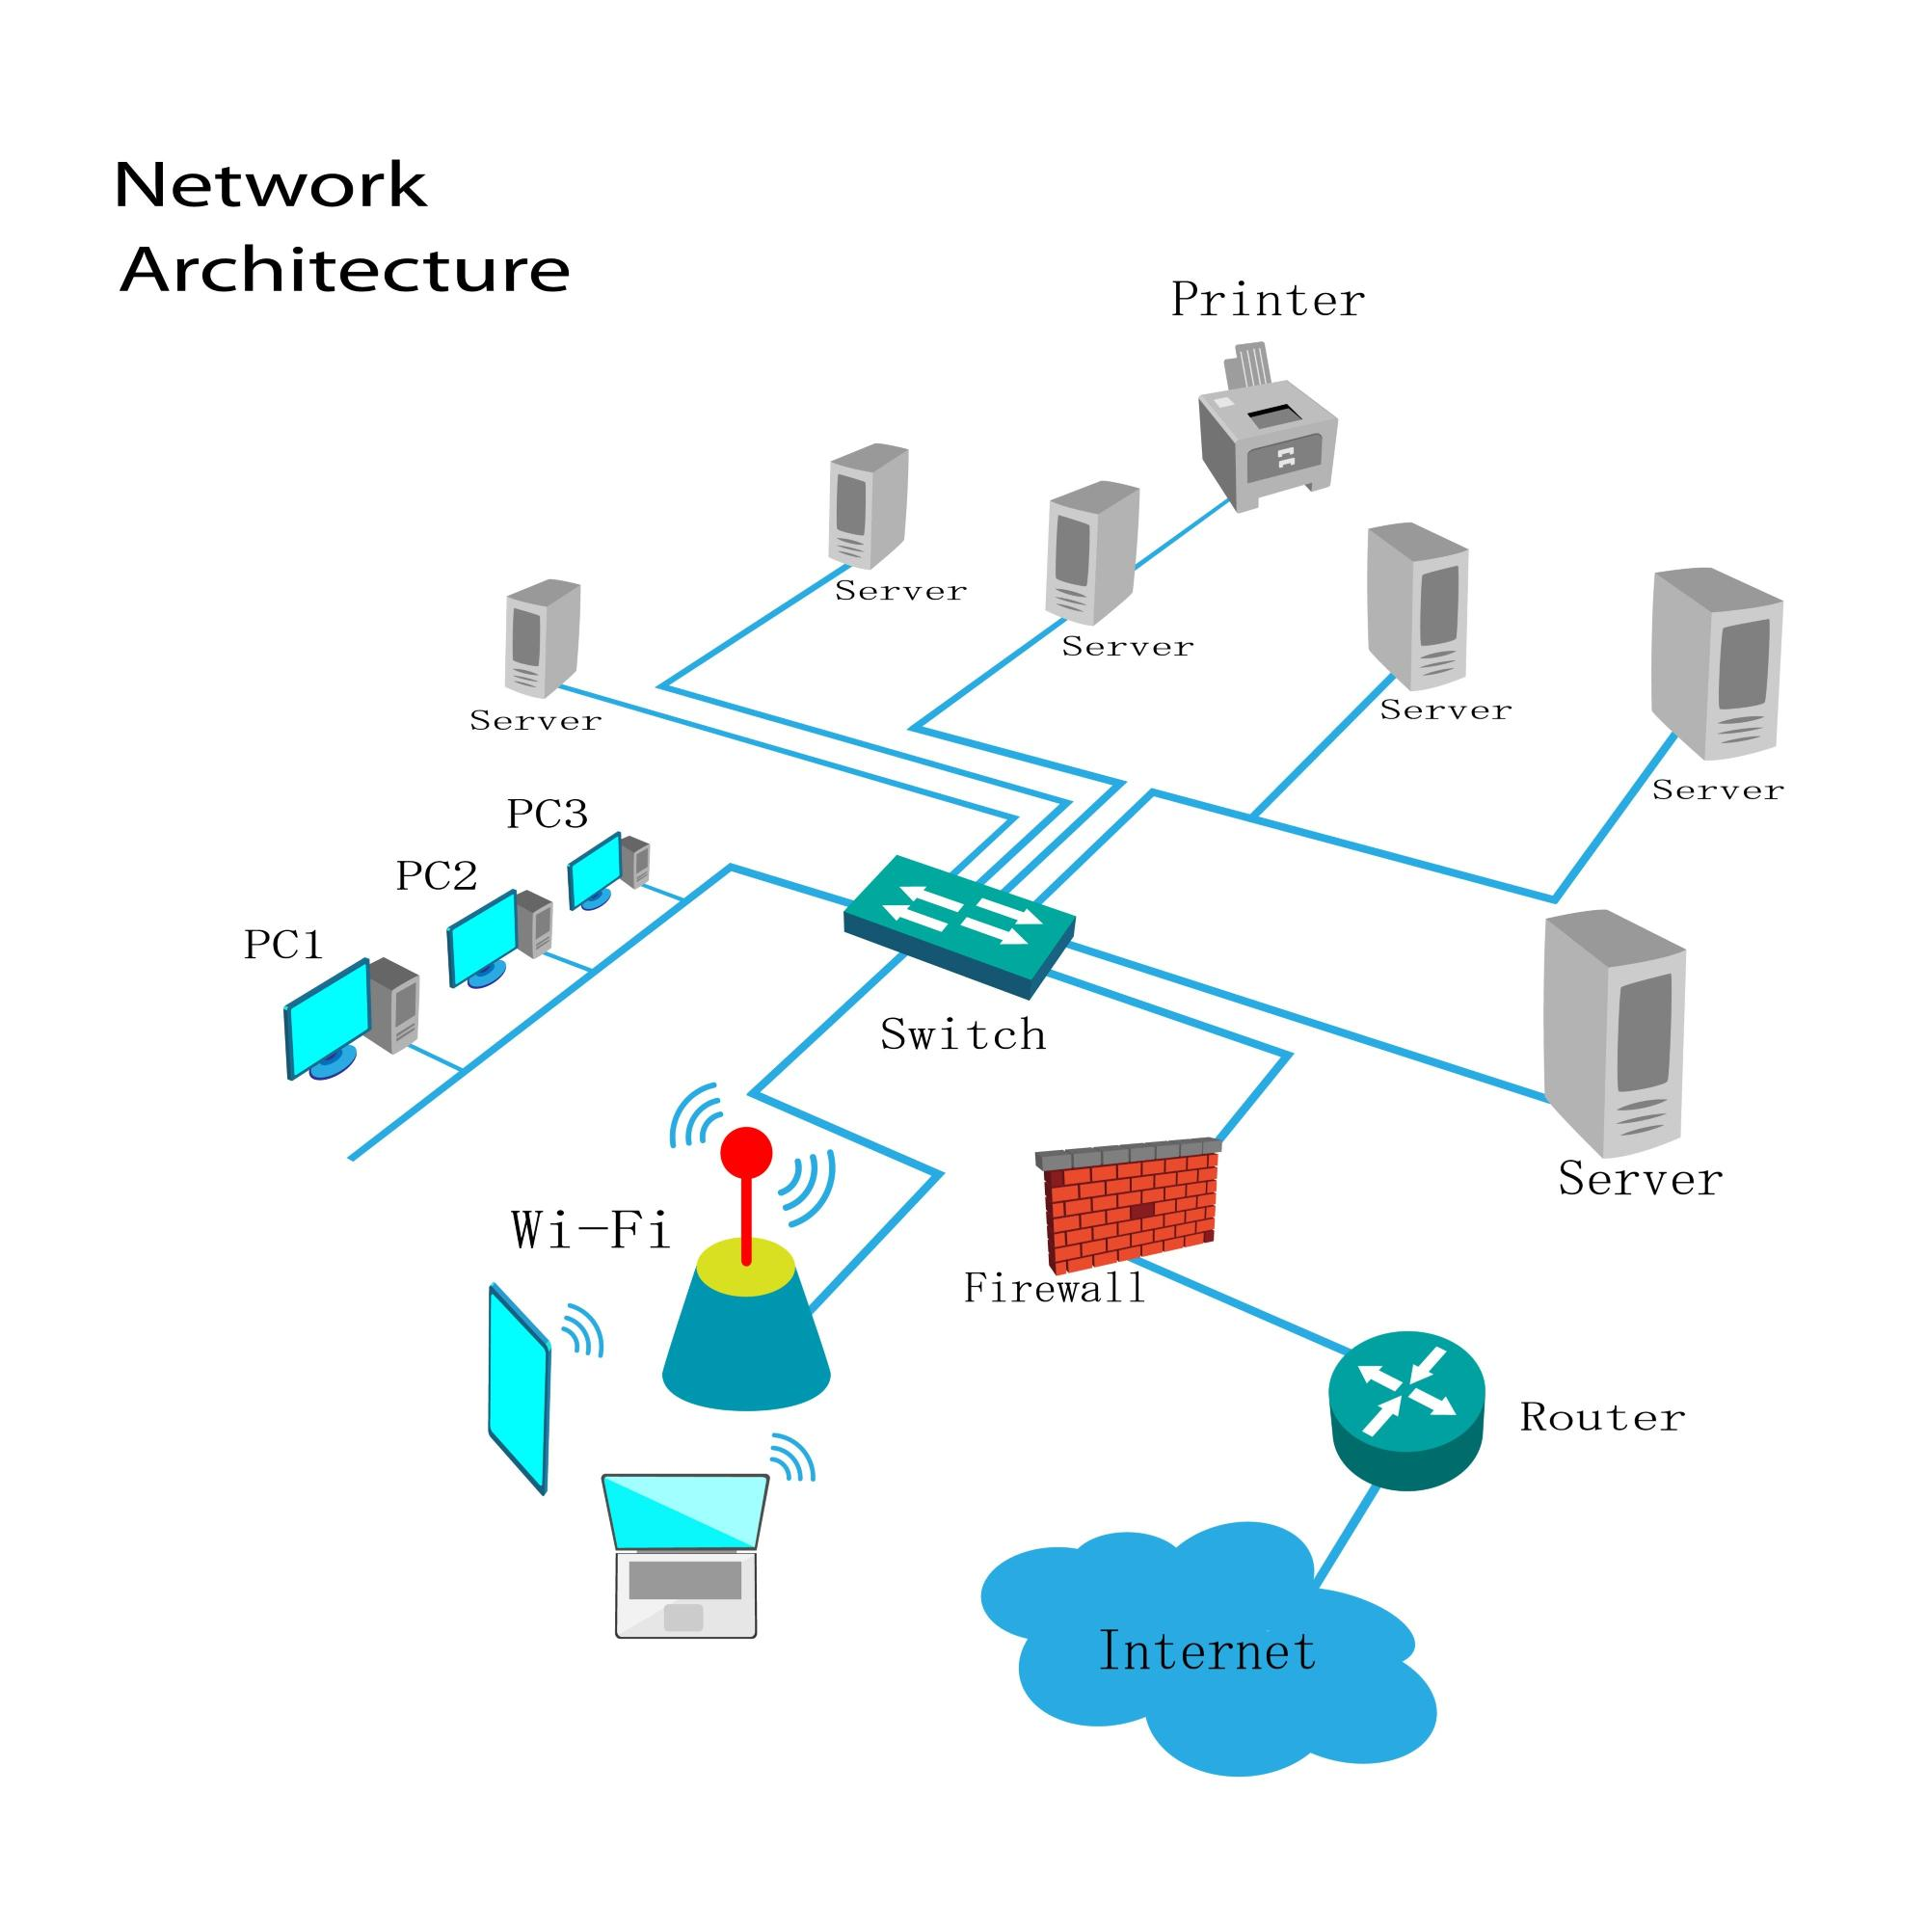Shutterstock

### 9.2 Mobile TCP Issues

* **The Problem:** Standard TCP assumes packet loss = Network Congestion. It reacts by slowing down (Slow Start).
* **Wireless Reality:** Packet loss is often due to *handover* or *interference*, not congestion. Slowing down is the wrong reaction 28.
* **Solutions:**
  + **Indirect TCP (I-TCP):** Splits the connection at the base station. The fixed network uses standard TCP; the wireless leg uses a modified protocol29.
  + **Snooping TCP:** The base station "snoops" packets and retransmits lost ones locally without telling the sender to slow down30.

## Week 10: Wireless LANs (Wi-Fi, Bluetooth)

Lecture Duration: 3 Hours

Goal: Short-range networks.

### 10.1 Bluetooth (IEEE 802.15.1)

* **Ad-hoc Piconets:** One Master device controls up to 7 Active Slaves.
* **States:**
  + **Active:** Transmitting data.
  + **Sniff:** Sleeping, waking up occasionally to listen.
  + **Park:** Deep sleep, gave up address to save maximum power 31.
* **Scatternet:** When a device belongs to two Piconets (Slave in one, Master in another)32.

### 10.2 WAP (Wireless Application Protocol)

* **History:** Before smartphones (Android/iOS), WAP was used to browse the internet on feature phones.
* **Architecture:**
  + **WAE:** Wireless Application Environment (uses WML instead of HTML).
  + **WSP:** Session Protocol (Suspend/Resume).
  + **WTLS:** Security (Lightweight SSL).
  + **WDP:** Datagram Protocol (Transport) 33.
  + *Kenyan Context:* Early mobile banking interfaces and Safaricom Live portal were based on WAP/WML.

## Week 11: Satellite Communication

Lecture Duration: 3 Hours

Goal: Global coverage.

### 11.1 Satellite Orbits

* **GEO (Geostationary):** 35,786 km high. Stationary relative to earth.
  + *Use:* TV Broadcasting (DStv), Weather.
  + *Pros/Cons:* Large footprint, but high latency (delay).
* **LEO (Low Earth Orbit):** 500–1,500 km high. Moves fast.
  + *Use:* Satellite Internet (Starlink), Satellite Phones (Iridium).
  + *Pros/Cons:* Low latency (good for internet), but needs many satellites for coverage.

### 11.2 Access Techniques (DAMA)

* **DAMA (Demand Assigned Multiple Access):** Satellites are expensive. Channels are assigned only when needed.
* **Mechanism:** Users contend for a channel in a "Reservation Phase" (Slotted Aloha). If successful, they get a dedicated slot in the "Data Phase" 34.

## Week 12: Distributed Computing & MANETs

Lecture Duration: 3 Hours

Goal: Infrastructure-less networking.

### 12.1 MANETs (Mobile Ad-Hoc Networks)

* **Definition:** A network of mobile nodes without a central tower/router. Every phone is a router 35.
* **Routing Protocols:**
  + **Proactive (DSDV):** Maintains lists of all routes all the time. Fast but wastes battery36.
  + **Reactive (AODV/DSR):** Finds a route only when you want to send a message. Saves battery but has initial delay37373737.

### 12.2 Security in MANETs

* **Black Hole Attack:** A malicious node lies that it has the fastest route, attracts all packets, and deletes them38.
* **Wormhole Attack:** Two attackers tunnel traffic between them to confuse the network routing39.

### 12.3 Mobile Databases

* **Hoarding:** Downloading data to the device to work offline (e.g., downloading Netflix movies or Google Maps offline areas)40.
* **Consistency:** Ensuring the offline copy matches the server data.
  + **Invalidation Reports:** The server sends a small message: "Hey, this data changed, download it again"41.

## Week 13 & 14: Examination

**Activities:** Revision of Past Papers, Project Presentations, and Final Written Exam covering Units 1–8.